Brandon Kmiec, Assignment 3, CSC 155 Section 2, Spring 2024

1. Screenshot of running program

1. Description of lighting
   1. The first light is a positional light and it is located at 5,5,5. The positional light is able to be moved with the mouse wheel and can be enabled/disabled.
   2. The second light is a global ambient light. The global ambient light is only enabled when the positional light is disabled.
2. Camera controls
   1. W – move forward
   2. S – move backward
   3. A – move left
   4. D – move right
   5. Q – move up
   6. E – move down
   7. Up Arrow – pitch up
   8. Down Arrow – pitch down
   9. Left Arrow – yaw left
   10. Right Arrow – yaw right
   11. Comma – roll left
   12. Period – roll right
3. Light controls
   1. Scroll Wheel – moves light if a direction is enabled
   2. X – toggle x axis movement (disabled by default)
   3. Y – toggle y axis movement (disabled by default)
   4. Z – toggle z axis movement (disabled by default)
   5. O – toggle positional light (on by default)
4. Matrix Stack usage
   1. A matrix stack was used for the movement and rotation of the imported object and the pyramid which are visible on the top left of the running program image.
5. Requirements I was unable to get fully working
   1. Materials
      1. Eight materials are used. Three from the book (gold, silver, bronze), one from <http://www.barradeau.com/nicoptere/dump/materials.html> (chrome), and three from <https://globe3d.sourceforge.io/g3d_html/gl-materials__ads.htm> (red, blue, green, and yellow color materials). The materials may not appear clearly because of the lighting or because some materials were applied to objects with textures that are similar in color.
      2. Materials are not rendered when the positional light is disabled
   2. XYZ axis
      1. The xyz axis do not have color when the positional light is disabled
6. Source for each texture and model used
   1. Wrinkled Page
      1. 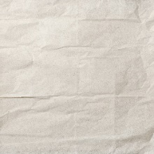
      2. Not made by me
      3. Obtained from <https://freestocktextures.com/texture/white-paper-sheet-wrinkled,1648.html>
      4. Creative Commons Zero License: <https://freestocktextures.com/license/>, <https://freestocktextures.com/support/>
   2. Ice
      1. 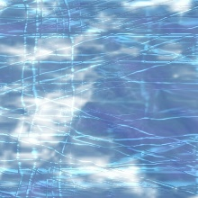
      2. Not made by me
      3. Provided by the textbook
   3. Brick
      1. 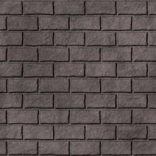
      2. Not made by me
      3. Provided by the textbook
   4. Custom Texture
      1. 
      2. Made by me using Microsoft Paint
      3. Originally made for CSC 165
   5. ComplexCube Imported Model
      1. 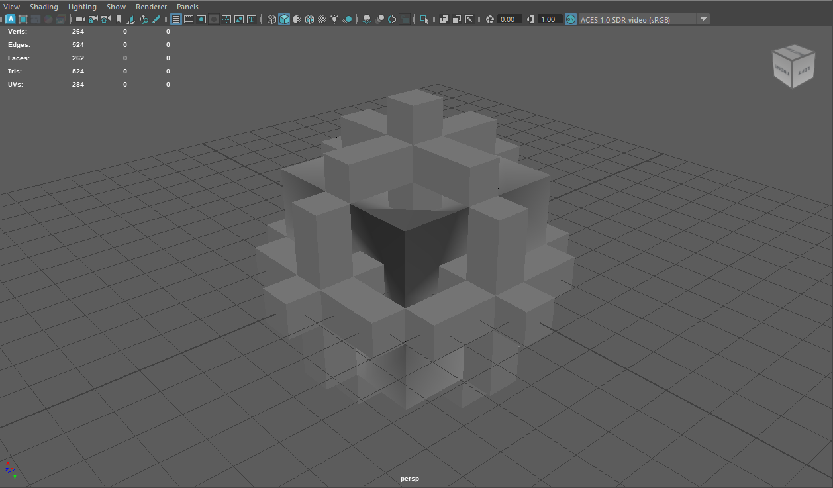
      2. Made by me
      3. Originally made in Maya for CSC126/ART142
   6. Skybox textures
      1. 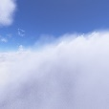A cloudy sky with clouds

         Description automatically generatedA blue sky with clouds and the sun

         Description automatically generatedA blue sky with clouds

         Description automatically generatedA close-up of clouds and blue sky

         Description automatically generated
      2. Not made by me
      3. Provided by the textbook companion files (prog 9_2)
   7. Sphere imported model
      1. A screenshot of a computer

         Description automatically generated
      2. Made by me using maya
7. Tested on RVR-5029 SNEEZYMUD